Chair Recruitment Pack
Introduction
Sampad’s mission is to connect people with South Asian and British Asian Arts and Heritage, and to play a cutting-edge role in the creative economy and has a 30-year track record.
Having recently been renewed within the national portfolio of Arts Council England, we are moving into a new era: we have an exciting programme of work across a variety of art forms, communities across the region and will interrogate themes and issues around colonialism.
We are looking to recruit a new Chair of our volunteer Board of Trustees to oversee the strategy and execution of the organisation’s activities.
About Sampad
Sampad believes in the power of arts and heritage to impact widely on all communities towards bringing people together from all walks of life.
- Celebrating South Asian Arts & Heritage
- Breaking down barriers
- Amplifying unheard voices
Moving beyond 30 years, we continue to play an instrumental role in promoting and encouraging British Asian arts, so that they progress, break new ground and enrich mainstream culture in the UK. We support, commission and co-produce a huge variety of arts and heritage activities inspired by diverse artforms that originate from India, Pakistan, Bangladesh and Sri Lanka.
We have a strong track record of delivering high-quality dance, music and theatre productions, digital events and workshops in education, community and outreach settings. We also provide professional development for artists, cultural leaders and young people. We are now developing and growing our learning programme with a new team in place.
We receive kind support from Arts Council England and Birmingham City Council and work closely and strategically with Midlands Arts Centre, where we are based.
Sampad is also a member of Culture Central – a collective voice for culture in Birmingham.

www.sampad.org.uk
Sampad is supported by:

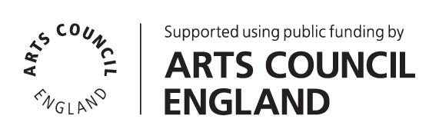

About the role of the Board
Sampad is a registered charity.
Board members of Sampad ensure that:
- we fulfil our mission;
- act to ensure that we meet our legal, charitable and financial obligations; and
- support the growth and development of Sampad as an organisation.

The Board is responsible for:
- agreeing Sampad’s strategic direction and policies;
- agreeing, overseeing and monitoring the implementation and progress against short- and long-term goals and key performance indicators; and
- helping it secure sustainable income streams to deliver its work.

The duties of all board members are as follows:
- Ensuring that the organisation pursues its stated objects (purposes), as defined in its governing document (i.e. its memorandum and articles of association), by developing and agreeing a long-term strategy.
- Ensuring that the organisation complies with its governing document, charity law, company law and any other relevant legislation or regulations.
- Ensuring that the organisation applies its resources exclusively in pursuance of its charitable objects for the benefit of the public.
- Ensuring that the organisation defines its goals and evaluates performance against agreed targets.
- Safeguarding the good name and values of the organisation.
- Ensuring the effective and efficient administration of the organisation, including having appropriate policies and procedures in place.
- Ensuring the financial stability of the organisation.
- Protecting and managing the property of the charity and ensuring the proper investment of the charity’s funds.
- Following proper and formal arrangements for the appointment, supervision, support, appraisal and remuneration of the members of the Senior Management Team (SMT).
- Responsibility for monitoring and reporting to Arts Council England against its funding targets 2023 -2026.

In addition, each board member should use any specific skills, knowledge or experience they have to help the Board reach sound decisions. This may involve scrutinising board papers, leading discussions, focusing on key issues and providing advice and guidance on new initiatives or other issues in which they have special expertise.
Each member is expected to avoid any conflicts of interest in their work for Sampad and to be watchful of any activities affecting Sampad that may be detrimental to the integrity or reputation of the organisation. Each member is required to sign a conflict of interest policy upon joining the Board.

Board members are expected to understand and abide by the Sampad mission statement, its charitable objects and articles of association and to respect the confidentiality of all Sampad business they discuss.

Board members are expected to maintain the highest standards of personal behaviour and professional conduct in relation to each other, Sampad staff and all others connected with the organisation and avoid any conflict of interest or other activity that would reflect negatively on Sampad.

The Board will hold periodic evaluations of its own performance to ensure it adheres to the standards it has set for itself and its practice.

Chair of the board - What we are looking for
Most importantly, we need you to be passionate about our mission. We also need you to:
- Be an advocate and ambassador
- Be present and participate
- Bring your expertise
- Give your time
- Be a supportive and critical friend

The current Chair Ranjit Sondhi CBE has been in role for the 25 years playing a crucial role in the organisation’s development. As outgoing chair he will play a pivotal role in overseeing and supporting the incoming Chair. We hope that this process will be complete by November 2023. The term for the position of Chair is 4 years with the possibility of a 2-year extension by prior agreement.
About the role of Chair
In addition to the roles of all board members set out above, the Chair will also carry out these additional roles.

- Oversees Board and executive committee meetings and calls special meetings if necessary.
- Ensures a balanced contribution by board members at meetings.
- Acts as a trusted advisor to the SMT as they develop and implement Sampad’s strategic plan.
- Works in partnership with the SMT to make sure Board resolutions are carried out.
- Appoints all committee chairs, and with the Director, recommends who will serve on committees and working parties.
- Assists the Director in preparing the agenda for board meetings.
- Assists the Director in inducting new board members.
- Oversees searches and the recruitment process for a new Director in partnership with a recruitment or succession committee.
- Coordinates the Director’s annual performance review.
- Acts as an alternative spokesperson for the organisation.
- Periodically consults with board members on their roles and helps them assess their own performance.
- Brings experience of relationships with key stakeholders and funders and an understanding of their strategies and goals
- Agrees annual and long-term goals and plans in partnership with the Director and staff to ensure the greatest reach and quality of Sampad’s programme and work
- Reviews outcomes and metrics created by Sampad to evaluate its impact and regularly measure its performance and effectiveness using those metrics.
- Monitors, has oversight of and ensures progress against set targets and outputs (KPIs, success measures and ACE Investment Principles)
- Monitors Sampad’s organisational risk register and act to ensure that it mitigates any key risks
- Approves the annual budget, audit reports, and material business decisions together with the rest of the Board
- Contributes to ensure that Sampad meets all its legal, charitable and financial responsibilities.

Person Specification
Essential qualities and experience.  You would be expected to meet all of these specifications | Desirable qualities and experience  (Please try to give examples of these in your application where you have this experience, skill or knowledge)
- A strong familiarity with South Asian or intercultural Arts and Culture across one or more artforms  - An active commitment to and understanding of inclusion, equal opportunities and anti-racism  - A commitment to the organisation, including a willingness to devote the necessary time and effort  - Strategic vision and independent judgement  - An ability to think creatively  - An understanding and acceptance of the legal duties, responsibilities and liabilities of trusteeship  - A commitment to Nolan’s seven principles of public life: selflessness, integrity, objectivity, accountability, openness, honesty and leadership  - Leadership and team building skills  - Tact and diplomacy  - Good communication and interpersonal skills  - Impartiality, fairness and the ability to respect confidences  - Financial expertise and confidence  - Highly networked individual with strong advocacy skills | - Understanding of the wider arts political and policy and cultural industries  - Ability to write or speak on policy/ cultural trends relating to the work of Sampad  - Awareness of Health & Safety practices and procedures  - Awareness of Safeguarding practices and procedures  - Knowledge of good recruitment practice  - Experience of committee work
Time Commitment
The board meets six times a year in Birmingham. The Chair will also be expected to form part of at least one board sub committees which also meets 6 times a year between scheduled board meetings. In addition to meeting attendance the Chair will be expected to attend, and sometimes speak at Sampad events and launches as well as other cultural sector events (average of one per month), such as events for Chairs and executives specially convened by the Arts Council.

We are a diverse led organisation committed to equal opportunities and aim to reflect this with a diverse board.

In addition, the Chair makes time for reading relevant documents and financial papers, preparing agendas, making queries of and responding to queries from the Director. They will also act as an ambassador for the organisation, attending events and functions on Sampad’s behalf as described above as well as actively networking and introducing opportunities to the company.
This position is voluntary and is an uncompensated role. Reasonable expenses e.g., travel to meetings incurred in carrying out work for Sampad may be reimbursed.

We estimate the time commitment is approximately 12-16 hours per month for the Chair.

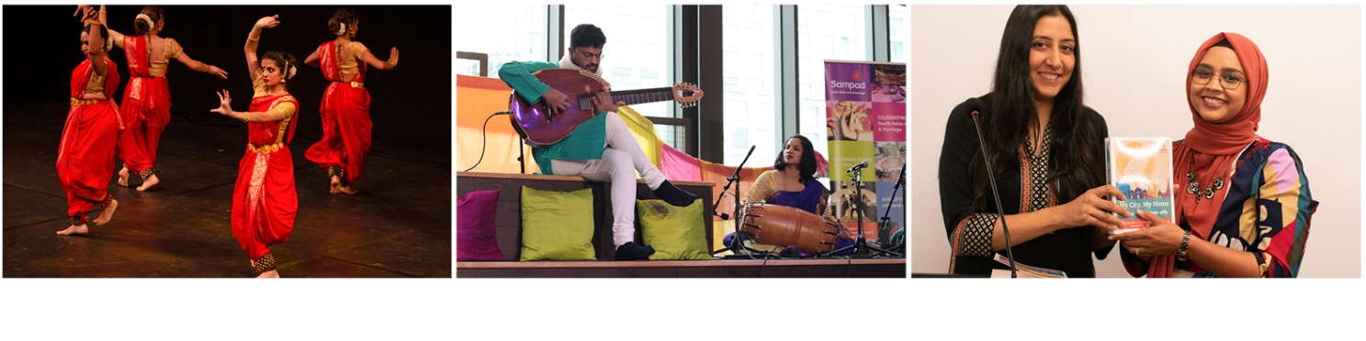Recruitment timeline
Closing Date for Applications: 26th May 2023 at 6pm
Interviews: Wednesday 21 June 2023 in person at MAC or online. Reasonable travel expenses will be re-imbursed to all interviewees.
How to apply
If you’re interested in applying for the role of Chair but would like an informal conversation first, please contact Helga Henry to set this up (helga@helgahenry.com). Helga is an independent arts consultant who is supporting our search for a new Chair.

To apply, please send two pieces of information:
your CV (no more than 2-3 pages in length); and
- either write a 2 or 3-page outline (no more than 3 pages) of why you would like to become the next Chair of Sampad and what skills and experience you could bring to the role; or
- if you prefer, you can send us a video of no more than 3 minutes’ duration of yourself describing why you would like to become the next Chair of Sampad and what skills and experience you could bring to the role.

Send your application to helga@helgahenry.com before 6pm on 26th May 2023 with the subject line ‘Application for Chair of Sampad’s Board’. Helga will acknowledge receipt of application within 2 working days.

April 2023
www.sampad.org.uk

For more details see: https://www.gov.uk/government/publications/the-7-principles-of-public-life/the-7-principles-of-public-life--2

